WORK-CASE №2

***Готував матеріал студент Мішин А.О.***

1.Install a type II hypervisor on your home workstation - Virtual Box, VMWare Workstation, Hyper-V (or another one of your choice).

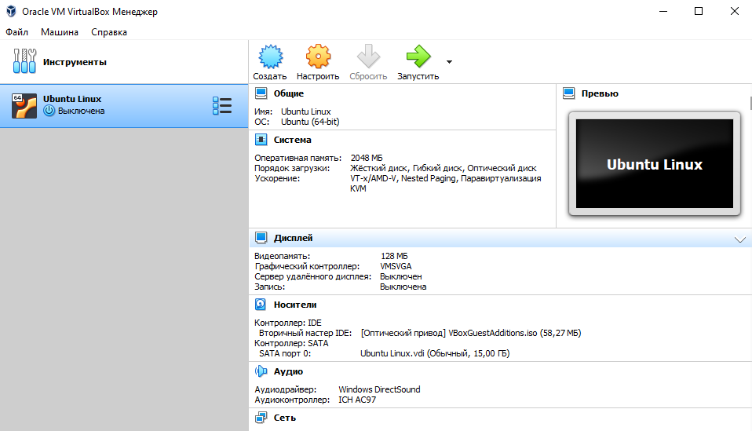

I installed Virtual Box:

 2.Describe a set of basic actions in the hypervisor you installed:

Here is a set of basic actions in VirtualBox:

* Create a new virtual machine:

Start VirtualBox on your computer.

In the upper-left corner of the window, click File and select New Virtual Machine.

In the virtual machine creation wizard, you will enter a machine name, select the type of operating system, and determine the amount of RAM.

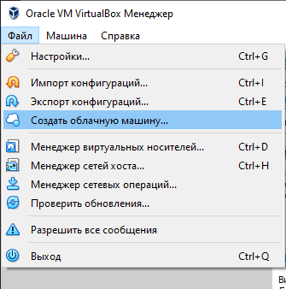

* Select/add available hardware:

After creating a virtual machine, select it from the list of available machines in the VirtualBox main window.

Right-click on the selected machine and select Settings.

In the machine settings window, you can configure various settings, such as the size of the virtual hard disk, the number of processors, the video card, and other hardware.

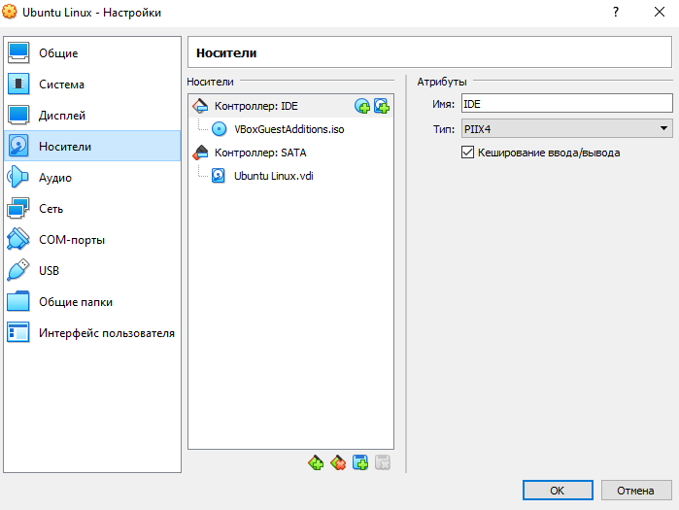

* Configure network settings and connect to Wi-Fi points:

In the virtual machine settings window, go to the Network section.

Here you can select a connection type, such as "Adapter 1," which will allow the virtual machine to access your computer's local network.

If you need to connect the machine to a Wi-Fi point, you can configure the network so that it uses a wireless adapter.

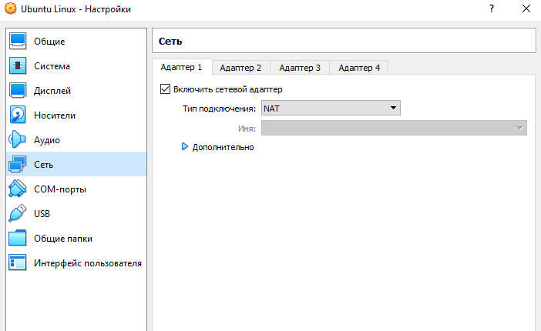

* Ability to work with external media (flash memory):

Turn on the virtual machine to which you want to connect external media.

In the main menu, select Devices and then USB.

Here you will see a list of available USB devices that can be connected to the virtual machine. Select the device you want to connect.

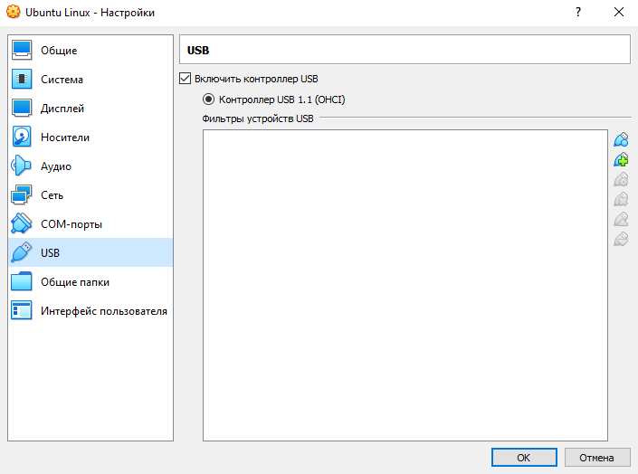

3.

Install the GNU/Linux CentOS operating system (or another convenient distribution) in your hypervisor in a basic configuration with a graphical shell.

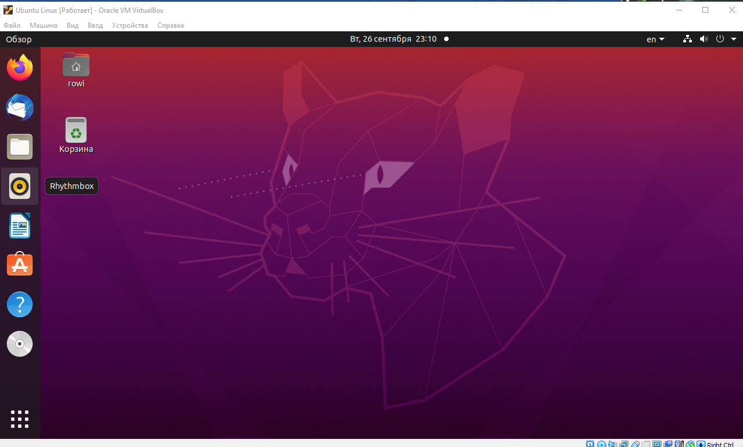

I installed Ubuntu Linux

**4. Create a virtual machine for a friend and select appropriate actions for it:**

**● Set to minimal configuration with terminal I/O**

**without a graphical interface, the GNU/Linux CentOS operating system;**

**● install the GNOME graphical shell on top of the one installed in**

**forward point OS;**

**● install an additional graphic shell (their possible overlap**

**can be found in laboratory robot No. 1) and equalize its capabilities with**

**GNOME.**

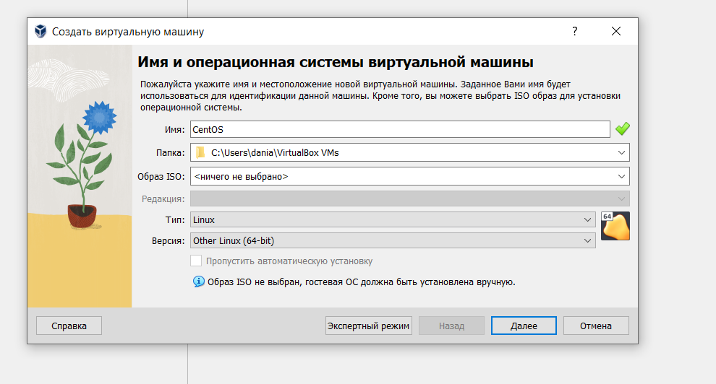

The new OS “CentOS” is being introduced into virtual box

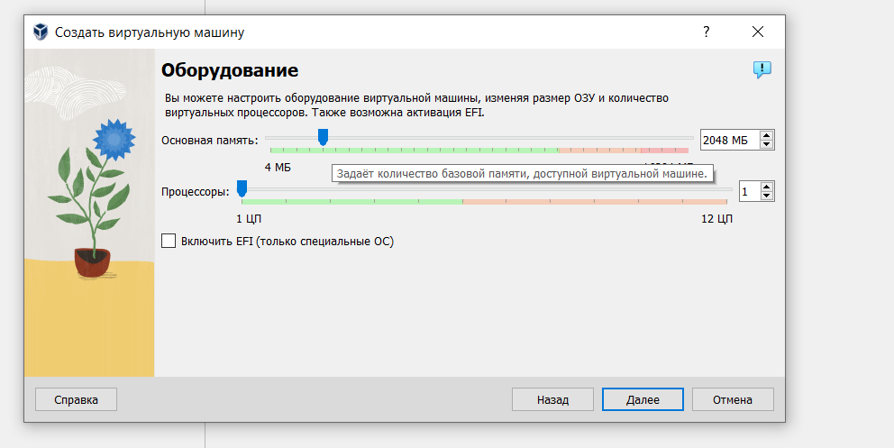 The memory value is set to 2048 MB

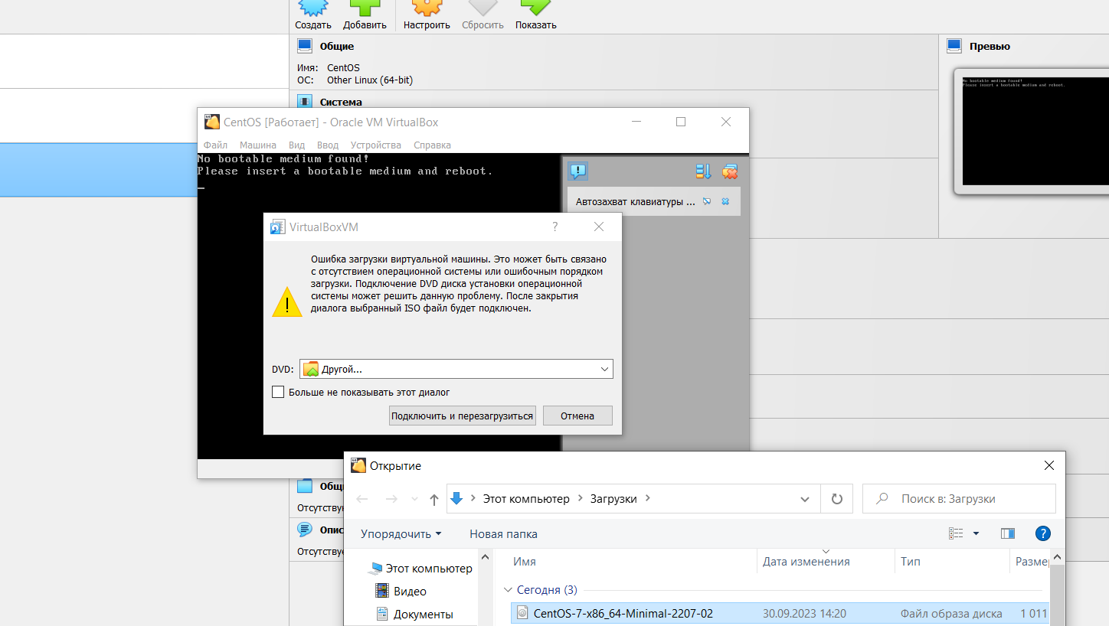

Select the OS image

Next, we enter our login and password into the CentOS system

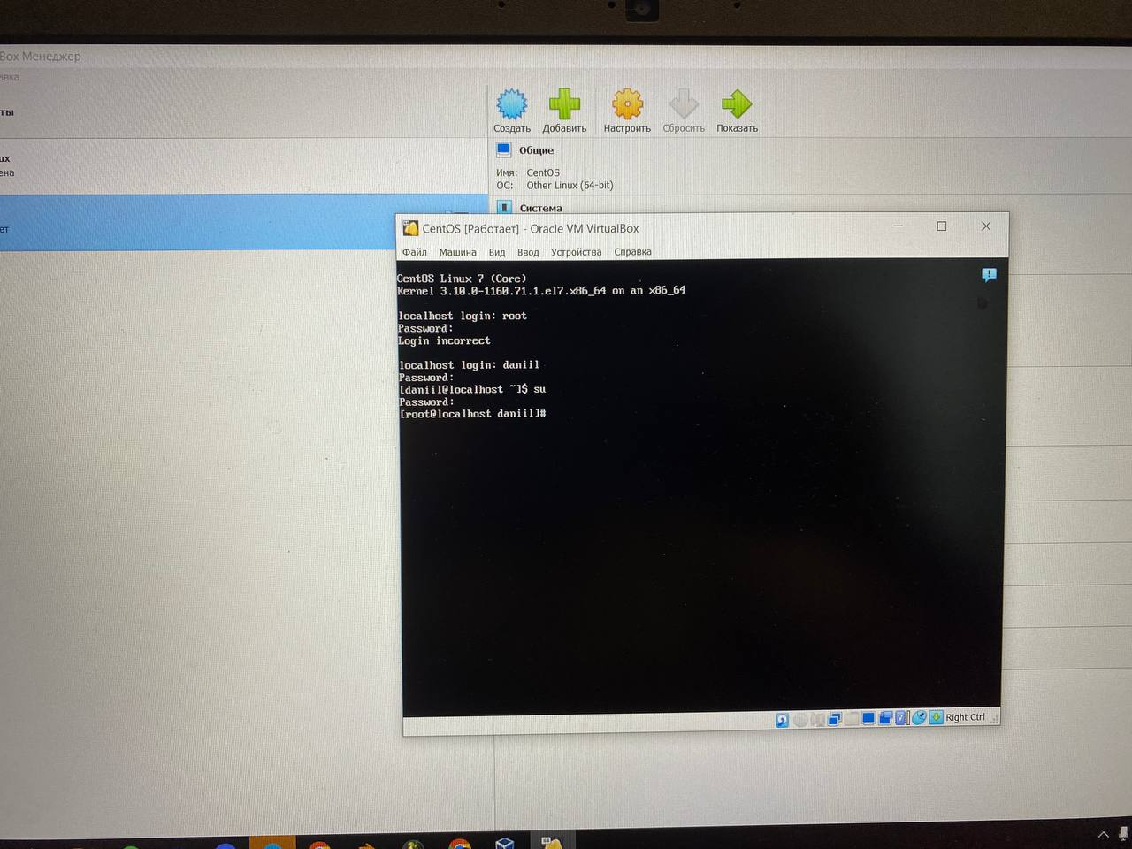

In the console we enter our specified values ​​previously

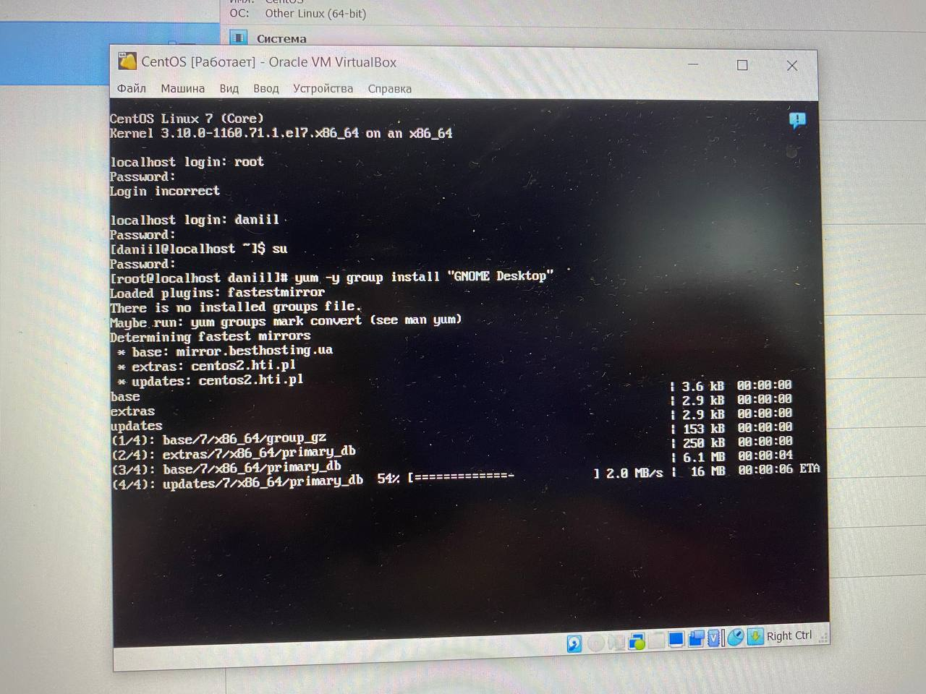

Install the GNOME Desktop graphical shell

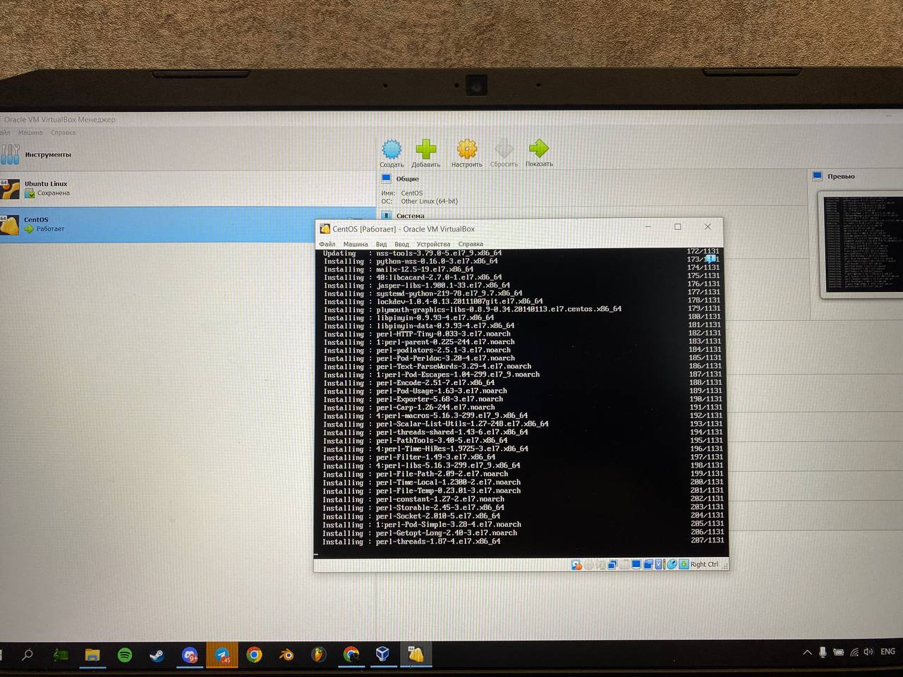

Cheers to the obsession with GNOME

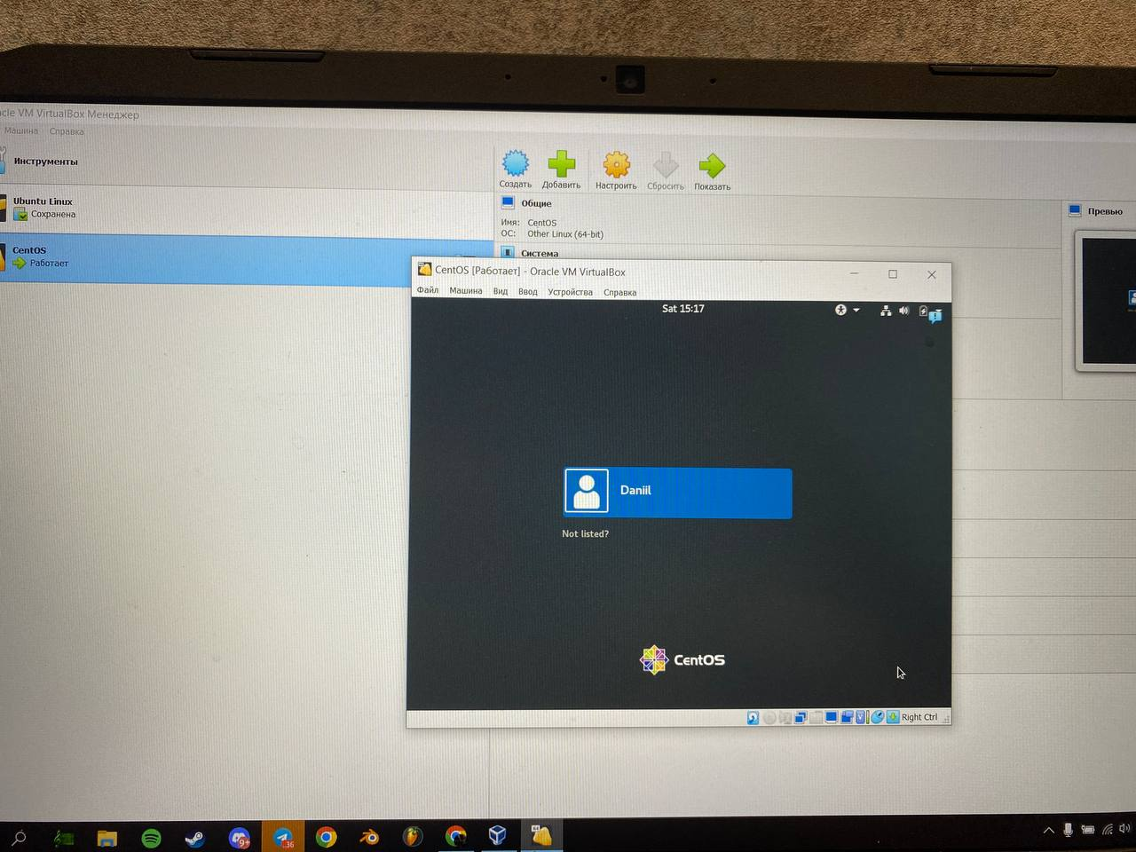

We go into the creation of a graphical shell and select a language

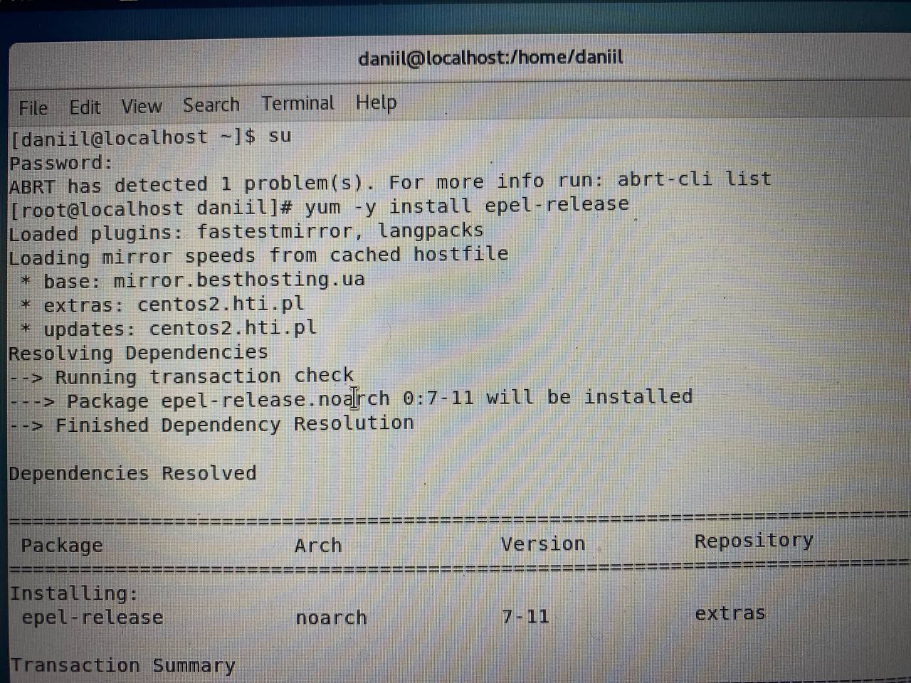

Let's go to the console and start creating another graphic

Obolonka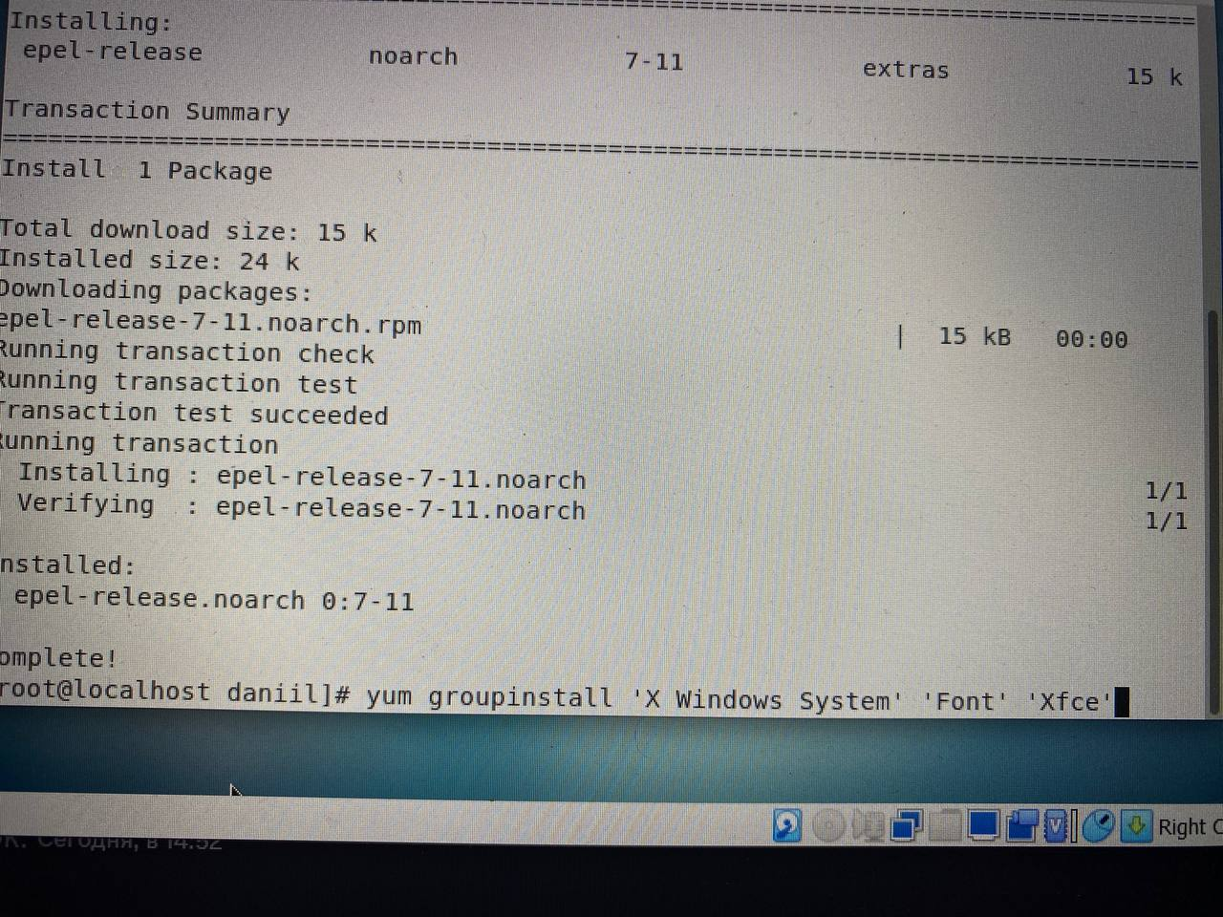

Install the package for the Xfce graphical shell

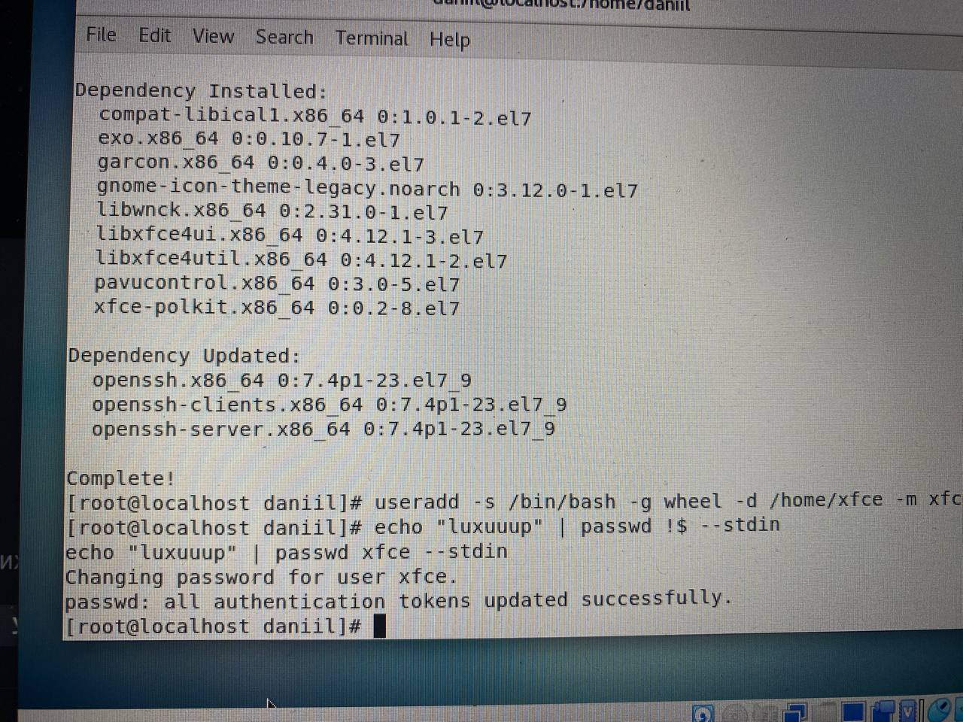

Create a password for a new password

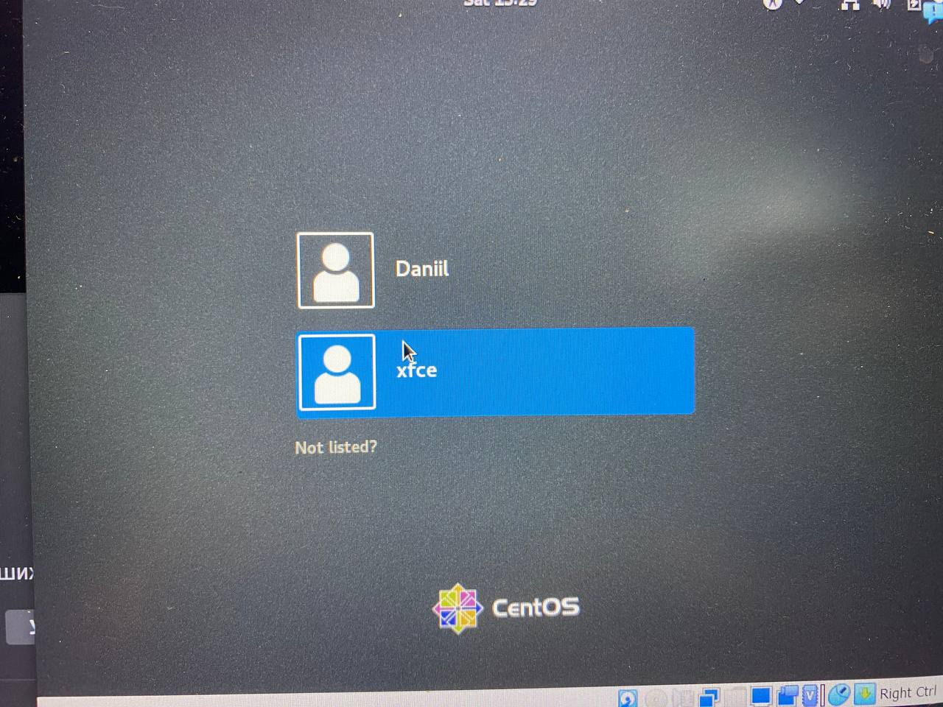

Entering the new koristuvach

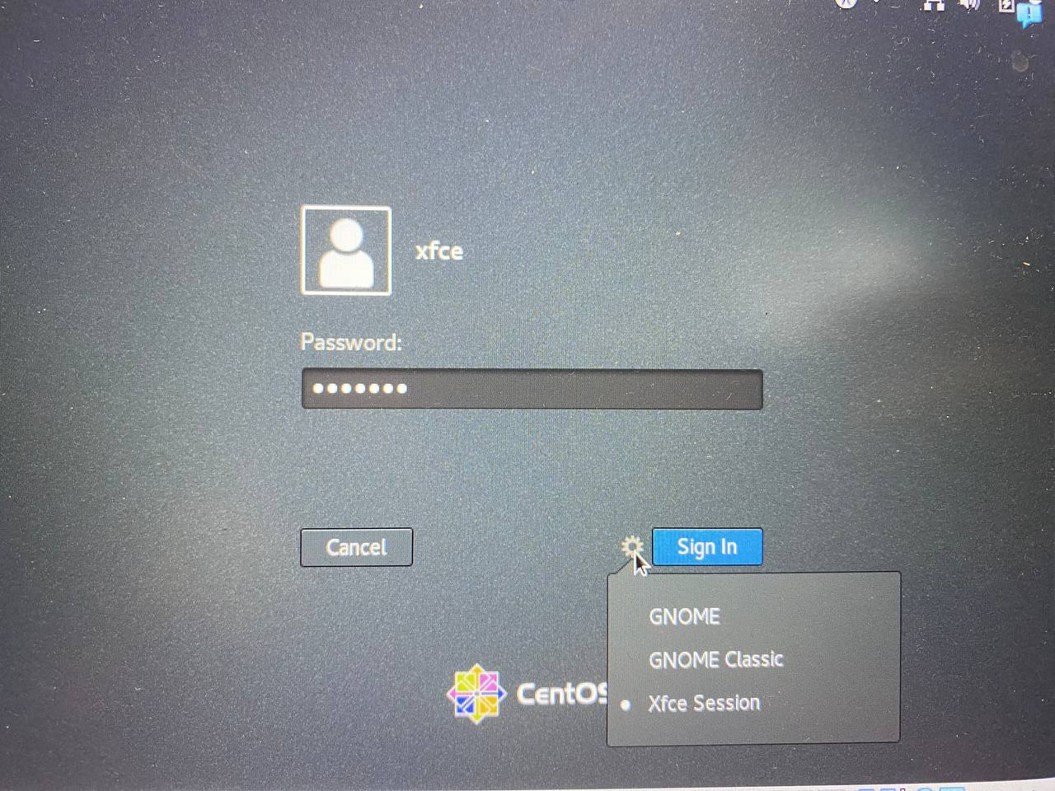

Enter the password and select the graphical shell of Xfce Session

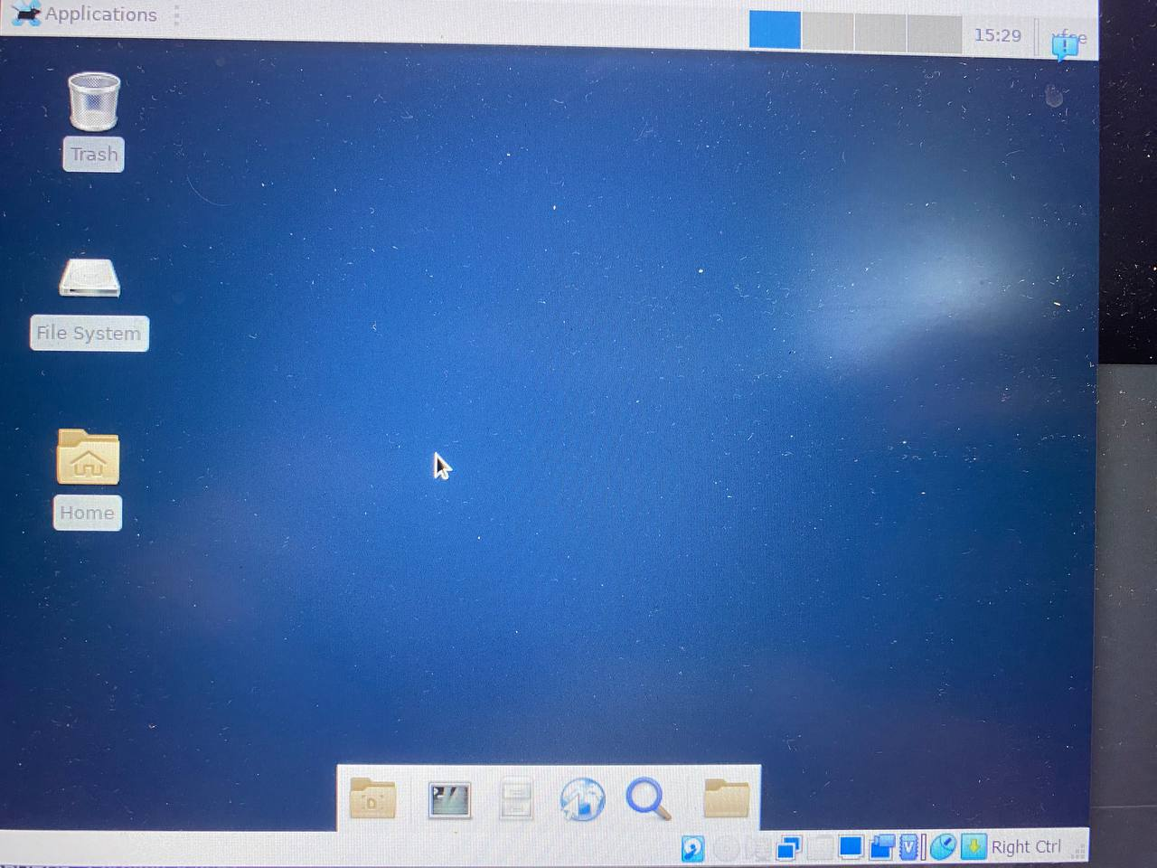

ВУАЛЯ все готово😊

XFCE and GNOME are two popular Linux desktop environments. Both have their own features and advantages, and the choice between them depends on your needs and preferences. Here's a comparison of XFCE and GNOME:

Resource Usage:

XFCE: XFCE is known for its lightweight nature and low system resource consumption. It can perform well on older computers or systems with limited resources.

GNOME: GNOME is heavier than XFCE and requires more computational power and RAM. It typically works better on modern computers.

User Interface:

XFCE: XFCE offers a classic and easily customizable interface. It provides more options for customization and offers a pleasant experience for users who enjoy customization.

GNOME: GNOME has a modern and streamlined interface focused on simplicity. It is less customizable out of the box but can be customized through extensions.

Workspaces:

XFCE: XFCE provides a significant number of workspaces and convenient ways to manage them.

GNOME: GNOME also supports workspaces, but they are implemented less visibly and are typically not used as extensively as in XFCE.

Extensions:

XFCE: XFCE has its own window manager and supports various extensions, although they may be less accessible and varied compared to GNOME.

GNOME: GNOME uses GNOME Shell, which supports a wide range of extensions, allowing you to extend its functionality and appearance.

Popularity:

XFCE: XFCE is popular among users looking for a lightweight and productive desktop environment.

GNOME: GNOME is also popular and is used in many Linux distributions, including Ubuntu.

In conclusion, both desktop environments have their advantages, and the choice between them depends on your hardware, workflow, and preferences. XFCE may be a better choice for older computers or those who prefer extensive customization, while GNOME may appeal to those seeking a modern and straightforward interface.